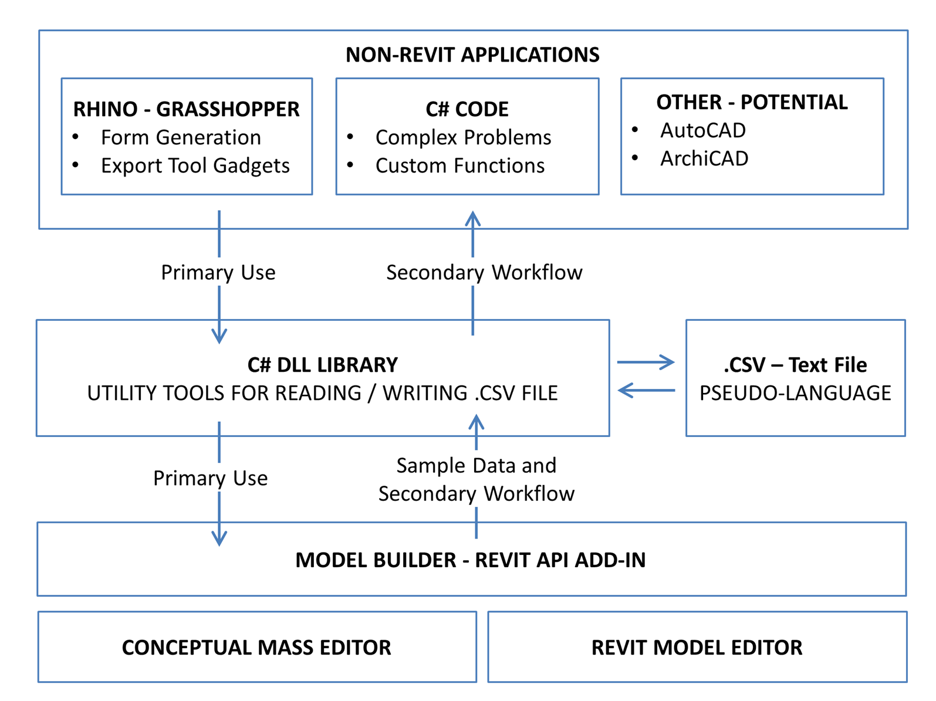

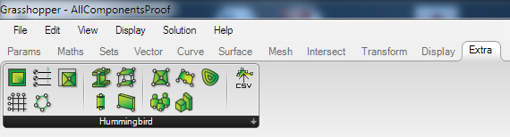

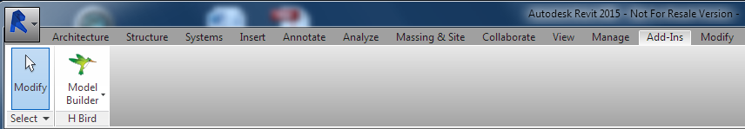

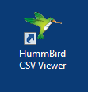

C:\DataWork\Work\WhiteFeet Software\Code - Hummingbird V2\HummingbirdGrasshopper\Hummingbird\Resources\Adap.png Adap C:\DataWork\Work\WhiteFeet Software\Code - Hummingbird V2\HummingbirdGrasshopper\Hummingbird\Resources\Beam.png Beam C:\DataWork\Work\WhiteFeet Software\Code - Hummingbird V2\HummingbirdGrasshopper\Hummingbird\Resources\Column2.png Column C:\DataWork\Work\WhiteFeet Software\Code - Hummingbird V2\HummingbirdGrasshopper\Hummingbird\Resources\Family.png Family

 Filled Regions C:\DataWork\Work\WhiteFeet Software\Code - Hummingbird V2\HummingbirdGrasshopper\Hummingbird\Resources\Floor.png Floor C:\DataWork\Work\WhiteFeet Software\Code - Hummingbird V2\HummingbirdGrasshopper\Hummingbird\Resources\Grid.png Grid C:\DataWork\Work\WhiteFeet Software\Code - Hummingbird V2\HummingbirdGrasshopper\Hummingbird\Resources\Input.png Input

C:\DataWork\Work\WhiteFeet Software\Code - Hummingbird V2\HummingbirdGrasshopper\Hummingbird\Resources\Level.png Level C:\DataWork\Work\WhiteFeet Software\Code - Hummingbird V2\HummingbirdGrasshopper\Hummingbird\Resources\Lines.png Lines C:\DataWork\Work\WhiteFeet Software\Code - Hummingbird V2\HummingbirdGrasshopper\Hummingbird\Resources\LoftForm.png LoftForm C:\DataWork\Work\WhiteFeet Software\Code - Hummingbird V2\HummingbirdGrasshopper\Hummingbird\Resources\MassFamily.png MassFamily

C:\DataWork\Work\WhiteFeet Software\Code - Hummingbird V2\HummingbirdGrasshopper\Hummingbird\Resources\RoomsAreas.png RoomsAreas C:\DataWork\Work\WhiteFeet Software\Code - Hummingbird V2\HummingbirdGrasshopper\Hummingbird\Resources\Topo.png Topo C:\DataWork\Work\WhiteFeet Software\Code - Hummingbird V2\HummingbirdGrasshopper\Hummingbird\Resources\Wall.png Wall

